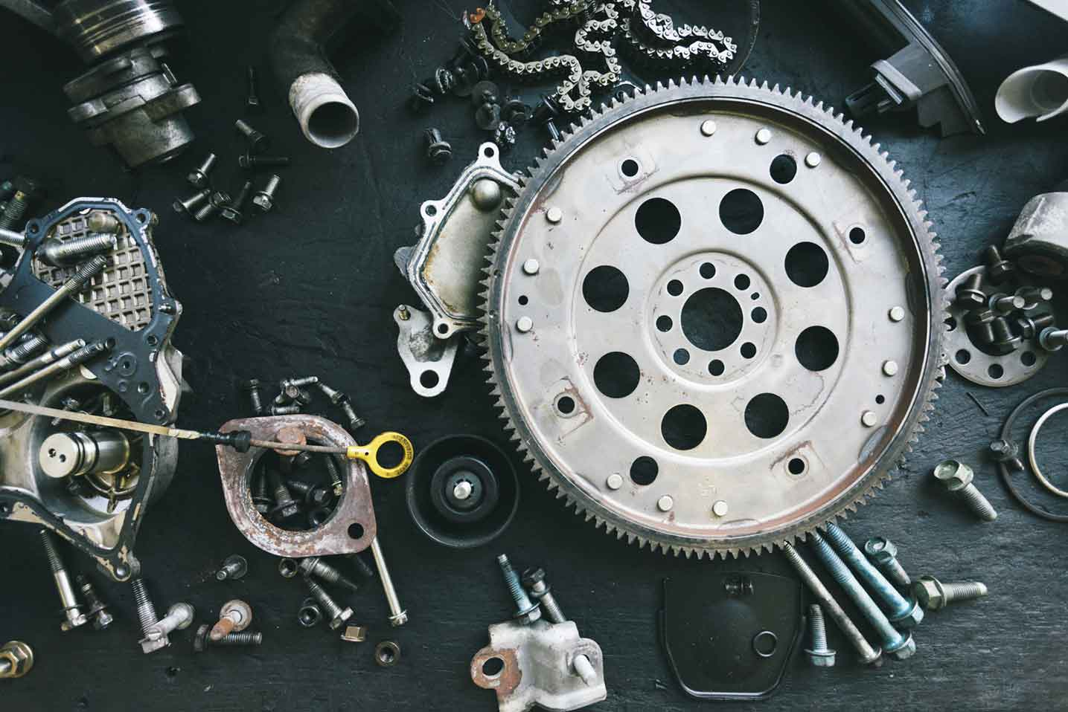­­­­­

|  |  |
| --- | --- |
|  |  |



Process Definition

Document

RPA Challenge

Automation of RPA Challenge

Table of Contents

I. INTRODUCTION 4

1.1 Purpose 4

1.2 Objectives 4

1.3 Key Contacts 5

1.4 Minimum Pre-requisites for the Automation 5

II. AS IS Process description 5

2.1 Process Overview 5

2.2 Applications Used 7

2.3 AS IS Process Map 7

2.3.1 High Level Process Map 8

2.3.2 Detailed Level Process Map 8

2.4 Process Statistics 8

2.5 Detailed As Is Process Actions 9

2.6 Exceptions Handling 9

2.7 Input Data Description 10

III. TO BE Process description 11

3.1. Detailed TO BE Process Map 11

3.2. Parallel Initiatives 11

3.3. In Scope For RPA 12

3.4. Out Of Scope for RPA 12

3.5. Exceptions Handling 12

3.5.1. Known Business Exceptions 12

3.5.2 Unknown Business Exceptions 13

3.6. Applications Errors & Exceptions Handling 13

3.6.1. Known Applications Errors and Exceptions 13

3.6.2. Unknown Applications Errors and Exceptions 13

3.7. Reporting 14

IV. Other 14

4.1. Additional sources of process documentation 14

# INTRODUCTION



## Purpose

The Process Definition Document outlines the business process chosen for automation. The document describes the sequence of actions performed as part of the business process, the conditions and rules of the process prior to automation (**AS IS**) as well as the new sequence of actions that the process will follow as a result of preparation for automation (**TO BE**).

**The PDD is a communication document between:**

* The RPA Business Analyst and the SME/Process Owner. The goal is to ensure that the RPA Business Analyst has the correct understanding of the process and has represented it accurately.
* The RPA Business Analyst and the Development team (represented by the Solution Architect and RPA Development Lead). The goal is to ensure that the process is documented appropriately and to a sufficient level of detail so that the Solution Architect can then create the solution based on the PDD content.

## Objectives

The business objectives and benefits expected by the Business Process Owner after automation of the selected business process are:

* Reduce processing time per item by 80%.
* Better Monitoring of the overall activity by using the logs provided by the robots.

## Key Contacts

Add here any stakeholders that need to be informed or to approve changes to the process:

|  |  |  |  |
| --- | --- | --- | --- |
| Role | Name | Contact Details (email, phone number) | Notes |
| Developer | Ujjwal Kumar |  |  |
|  |  |  |  |

## Minimum Pre-requisites for the Automation

1. Filled in Process Definition Document
2. Test Data to support development.
3. User access and user accounts creations (licenses, permissions, restrictions to create accounts for robots)
4. Credentials (user ID and password) required to logon to machines and applications.

# AS IS Process description

In this section the Business Analyst will document the process. This section will serve as the starting point for the re-engineering and automation effort.



## Process Overview

Section contains general information about the process before automation.

|  |  |
| --- | --- |
| Item | Description/Answer |
| Process Full Name | RPA Challenge |
| Process Area | Market & Finance |
| Department | Finance |
| Short Description (operation, activity, outcome) | Automation of RPA Challenge |
| Role(s) required in applications to perform the process |  |
| Process schedule and frequency | Daily once |
| Number of times the process is ran by selected frequency | 1 |
| Process execution time | 29.9 sec. |
| Process Restrictions | **e.g**. *This is necessary for the Solution Architect to decide how they will need to split the Master Project into smaller projects (the scheduling of the robots will depend on this)*  ***Example:*** *The applications can be used only between 7 AM-8PM during work days and not allowed to be used during weekend.* |
| Peak Period (s) | ***e.g.*** *It is important to understand peaks in order to design a robust and scalable solution.*  *Example:  Beginning of month, usually from 28th to 30th day of each month* |
| Peak Volume Approximate increase | ***E.g.*** *It is important to understand peaks in order to design a robust and scalable solution.*  *Example: 600* |
| Number of persons performing the process |  |
| Expected Volume increase during next periods |  |
| Percentage Un-handled exceptions |  |
| Input data description | ***Excel Input*** |
| Output Data description | **Success message** |

*Add more rows to the table to include relevant data for the automation process. No fields should be left empty. Use “n/a” for the items that don`t apply to the selected business process.

## Applications Used

The table includes a comprehensive list of all the applications that are used as part of the process to be automated to perform the given actions in the flow.

|  |  |  |  |  |  |
| --- | --- | --- | --- | --- | --- |
| Application Name | Version | Application Language | Thin/Thick Client | Environment/ Access method | Comments |
| RPA Challenge | [Rpa Challenge](https://rpachallenge.com/) | NA | Thick |  |  |
|  |  |  |  |  |  |
|  |  |  |  |  |  |
|  |  |  |  |  |  |

*Add more rows to the table to include the complete list of applications.

## AS IS Process Map

This section contains various process maps contributing to a better understanding of how the process is performed pre-automation.

### High Level Process Map

This section is useful for the Business Analyst in presentations and discussions with management to underline areas of weakness, inefficiency or to demonstrate which actions could be in scope for automation.

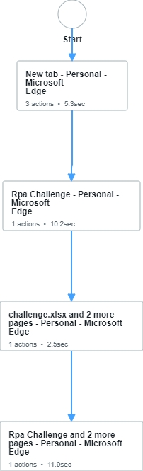

### Detailed Level Process Map

This section describes the process at key-stroke level and is an essential part for the communication with the developers.

## Process Statistics

**High Level statistics**

|  |  |  |  |  |  |  |  |
| --- | --- | --- | --- | --- | --- | --- | --- |
| Processes | Windows | Actions | Mouse clicks | Keys pressed | Text entries | Hotkeys used | Time |
| 1 | 4 | 6 | 4 | 0 | 0 | 1 | 29.9 sec. |
|  |  |  |  |  |  |  |  |
|  |  |  |  |  |  |  |  |

**Detailed statistics**

|  |  |  |  |
| --- | --- | --- | --- |
| Window name | Mouse clicks | Text entries | Key pressed |
| New tab - Personal - Microsoft​ Edge | 1 | 0 | 0 |
| Rpa Challenge - Personal - Microsoft​ Edge | 1 | 0 | 0 |
| challenge.xlsx and 2 more pages - Personal - Microsoft​ Edge | 1 | 0 | 0 |
| Rpa Challenge and 2 more pages - Personal - Microsoft​ Edge | 1 | 0 | 0 |
|  |  |  |  |
|  |  |  |  |

## Detailed As Is Process Actions

|  |  |  |  |  |  |
| --- | --- | --- | --- | --- | --- |
| #Action | Input | Description | Details (Screen/Video Recording Index) | Exceptions Handling | Possible Actions |
|  |  |  |  |  |  |
|  |  |  |  |  |  |

|  |  |
| --- | --- |
| 1. New tab - Personal - Microsoft Edge | |
|  | **Est. time: 5.3 sec.** |

|  |  |
| --- | --- |
| * 1. Launch RPA Challenge website url |  |
|  |  |
| image |  |

|  |  |
| --- | --- |
| * 1. Download Excel for Input and from input data we need to fill the data in the same website. Click on the START Button. |  |
|  | Est. time: 10.2 sec. |
|  | Action: Click |

|  |  |
| --- | --- |
|  |  |
|  | Est. time: 11.9 sec. |
| image | Action: Click |

## Exceptions Handling

## Input Data Description

The following table should contain details regarding the inputs that every action of the process takes.

|  |  |  |  |  |  |
| --- | --- | --- | --- | --- | --- |
| #Action | Sample | Input Type | Location | Are inputs Natively Digital*? | Are the Inputs Structured*? |
|  |  |  |  |  |  |
|  |  |  |  |  |  |
|  |  |  |  |  |  |

*\** ***Native Digital****: This is data that was originally created digitally e.g. excel, database or application reports etc. The non-native digital inputs are usually scanned images.*